CrikeyCon 2017

# Fast Math Solution by Michael ‘codingo’ Skelton

**Category**: Coding   
**Points**: 300  
**Solves**: 14  
**Description**: crikeyconctf.dook.biz:23776

## Probing the host

Before doing anything else on this host I attempted to ncat to it, receiving the following:

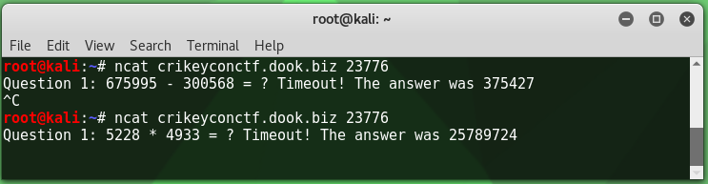

The time between being presented with the challenge and receiving a timeout was a mere two seconds. Although handy with a calculator this wouldn’t be possible without a script/bot. I also noted that the response and timing to answer didn’t change on a second connection, but the base operator did. I then felt comfortable writing a script to connect to the host and return an answer to basic math questions (+-/*).

## First answer script attempt

I put together a bot which would connect to the host and parse the challenge question using regex so it could answer it using an expression. This resulted in the following ~~spaghetti~~ code:

#!/usr/bin/python3

import socket

import re

import operator

MAXBUF = 4096

SENTINEL = 'flag'

CTF_BOT = ('crikeyconctf.dook.biz', 23776)

if __name__ == '__main__':

client = socket.socket(socket.AF_INET, socket.SOCK_STREAM)

client.connect(CTF_BOT)

while True:

data = b''

# receive and store data

while True:

chunk = client.recv(MAXBUF)

data += chunk

if len(chunk) < MAXBUF:

break

# store decoded data for future usage

decoded = data.decode('utf-8')

#temporary

print(decoded)

#

# our flag likely contains flag{}, once it's revealed print received data and exit

if SENTINEL in decoded:

print(decoded)

break

match = re.search('[^\:\s]\d+.{3}\d+', decoded)

if not match:

raise ValueError("Invalid expression string")

expression = match.group(0)

# properly handle division

if '/' in expression:

expression = expression.replace('/', '//')

result = eval(expression)

# print results to screen to see script progress

print(expression + ' = ' + str(result))

# encode and transfer

data = str(result).encode('utf-8') + b'\n'

print('Sending: ' + str(result))

client.send(data)

## Regular expression (attempt)

The most important line here was the regex which consisted of the following (see if you can spot the mistake!):

match = re.search('[^\:\s]\d+.{3}\d+', decoded)

This would skip everything proceeding the colon and whitespace and then group both sets of numbers, and the whitespace/operator between them for evaluation.

The response to this was the following:

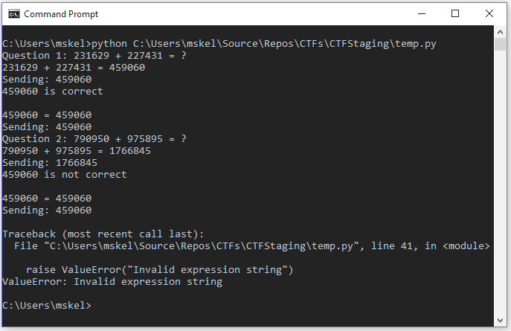

I spent far more time on this part of the challenge than I care to admit. I didn’t entirely read my logs and spent my time stuck on the two lines where I have *Sending 1766845* and the response *459060 is not correct* and put a lot of focus into trying to identify why a different response was being sent to what was calculated (not the truth, but it’s what I was thinking).

## Adding further regular expressions to catch x=x

Eventually I identified that the response to an answer was:

*AnswerProvided is correct  
AnswerProvided = AnswerProvided*

And then the next question would be presented. This was causing issues with my regex as I was passing values from the previous answer into my group, ultimately preventing the correct evaluation from sending.

I resolved this by continuing back to the beginning of my loop if there wasn’t a mathematical operator in my decoded string, putting this after the sentinel check as I didn’t want to miss my flag (which likely wouldn’t contain an operator). This looked like the following:

if not re.search('[-+/*]', decoded):

continue

## Updating regular expression to handle more than one digit

This got me to question number 10 – at which point I realised that my regex of:

match = re.search('[^\:\s]\d+.{3}\d+', decoded)

Would only work if I were to be presented with a single digit question. I updated this to the following:

match = re.search('[^\:\s]\d+\d+.{3}\d+', decoded)

Essentially the same as above, but it would now capture two digits over one as I didn’t expect the challenges to go past 99 (although could use \d* if they were to).

## Flag Reveal

After making the changes above and letting the bot run for fifty questions I was then rewarded with the flag (redacted):

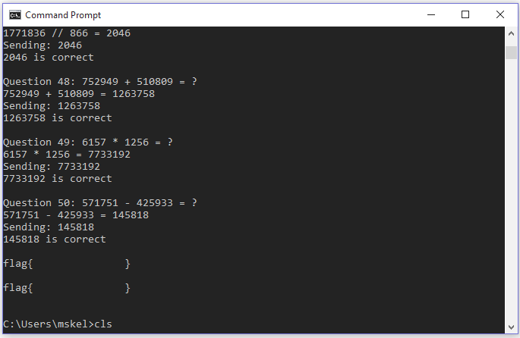

## Final Script

#!/usr/bin/python3

import socket

import re

import operator

MAXBUF = 4096

SENTINEL = 'flag'

CTF_BOT = ('crikeyconctf.dook.biz', 23776)

if __name__ == '__main__':

client = socket.socket(socket.AF_INET, socket.SOCK_STREAM)

client.connect(CTF_BOT)

while True:

data = b''

# receive and store data

while True:

chunk = client.recv(MAXBUF)

data += chunk

if len(chunk) < MAXBUF:

break

# store decoded data for future usage

decoded = data.decode('utf-8')

# print out response packet

print(decoded)

# our flag contains flag{}, once it's revealed print recevied data and exit

if SENTINEL in decoded:

print(decoded)

break

# bot sends the last answer back as x=x to confirm, skip this itteration

if not re.search('[-+/*]', decoded):

continue

match = re.search('[^\:\s]\d+\d+.{3}\d+', decoded)

if not match:

raise ValueError("Invalid expression string")

expression = match.group(0)

# properly handle division

if '/' in expression:

expression = expression.replace('/', '//')

result = eval(expression)

# print results to screen to see script progress

print(expression + ' = ' + str(result))

# encode and transfer

data = str(result).encode('utf-8') + b'\n'

print('Sending: ' + str(result))

client.send(data)